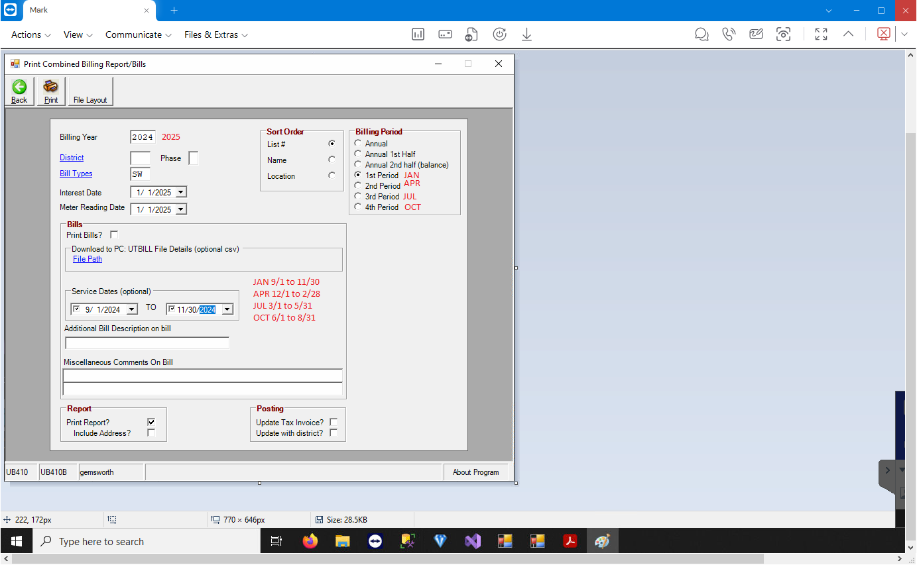

9/1/ thorough 11/30 for 1st qtr
SW combined

They only collect on WATER 2:00 min

SW qtrly
YZ MONTHLY

MONTHLY ub409 Uz example 1166

